Jenkins - Managing Plugins

To get the list of all plugins available within Jenkins, one can visit the link − <https://wiki.jenkins-ci.org/display/JENKINS/Plugins>

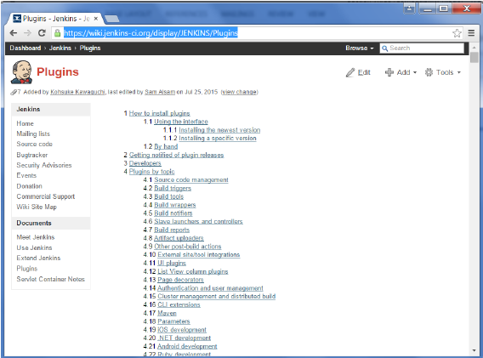

We’ve already seen many instances for installing plugins, let’s look at some other maintenance tasks with regards to plugins

Uninstalling Plugins

To uninstall a plugin, Go to Manage Jenkins → Manage plugins. Click on the Installed tab. Some of the plugins will have the Uninstall option. You can click these buttons to uninstall the plugins. Ensure to restart your Jenkins instance after the uninstallation.

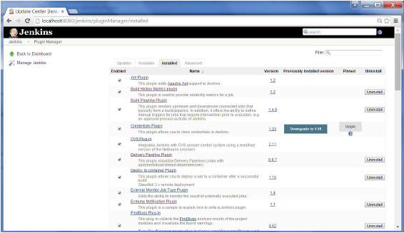

Installing another Version of a Plugin

Sometimes it may be required to install an older version of a plugin, in such a case, you can download the plugin from the relevant plugin page on the Jenkins web site. You can then use the **Upload** option to upload the plugin manually.

